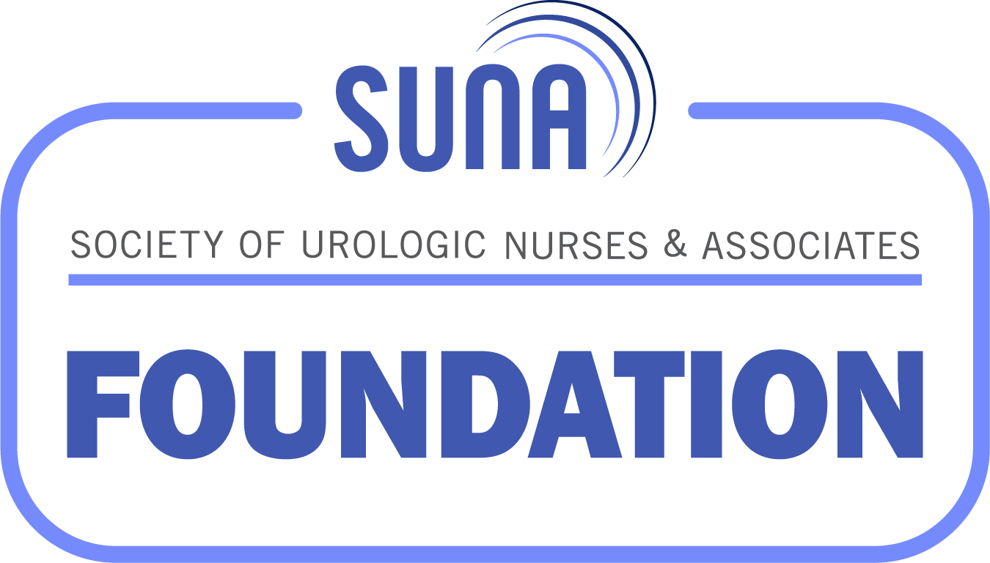

SUNA Foundation Silent Auction
Donation Form
October 26-27, 2023

Send completed forms to suna@ajj.com or fax to 856.589.7463 by October 13, 2023.

Contact Information:

Chapter or Individual:
Contact Name:
Phone Number: | Email:
Address:
City: State: |  | Zip:
Authorization to post donation level of support on the website: Yes ☐ No ☐
Suggested Donations:
- electronic devices
- sports or theater memorabilia
- chapter themed gift baskets
- nursing themed gifts
- tickets to sporting or cultural events
- vacation packages
- educational toys and software
- original artwork or crafts
- gift certificates
- medical books or journal subscription
- jewelry
- Use Your Imagination!

Briefly describe the item you are providing for the Silent Auction in the space below.
Please use a separate form for each item you wish to donate unless it is a set.
Please supply ALL requested information.

Donation Information:

Item or Service:
Estimated retail value:  List fair market value, not the price you paid if purchased on sale. | Special Restrictions:  expiration dates, limitations on days of use, exclusions, price caps, transferability, resale restrictions or anything else; i.e. what is the lowest bid you will accept
Description of Item/Service:
Photo Attached: Yes No
Donor’s Signature: |  | Date:

Please ship donated items to: Your Name/Guest
(if not attending then to Debbie Buback)
Arizona Grand Resort & Spa
8000 S Arizona Grand Pkwy
Phoenix, AZ 85044

Items must arrive at the hotel by Wednesday, October 25th.

If your donation is not a physical item, please provide promotional materials, including a description, brochure, and/or photo for display during the auction.

All donated items support SUNA Foundation activities (grants, scholarships, and education programs) and are tax deductible!
Thank you for your generous donation!

