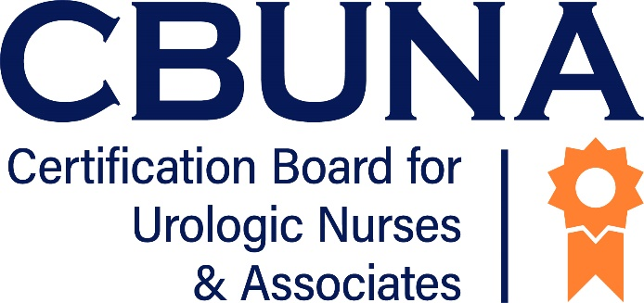
Get Involved
With
Would you like to be actively involved in CBUNA? You can be part of an established professional network, gain skills as an item writer, or join a committee or taskforce for your particular CBUNA credential.

Achieving certification through CBUNA attests to your commitment to provide quality nursing care to your patients. Becoming involved with CBUNA can enhances your professional image among your colleagues and your patients. The experience will help you grow personally and professionally, subsequently making you more respected in the urologic field.

CBUNA is a certification board run by volunteers. We recognize that your time is limited and that we are only one of many organizations seeking your help and expertise. Please consider joining us as we shape the future of certification. Together we can truly make a difference and meet the challenges that lie ahead.

CBUNA Willingness-to-Serve

Name (include credentials):
Home address:
Home or cell phone:
Email:
Employer:
Position:
Number of years CBUNA certified:
CBUNA Certification (check one): CUNP CURN CUA CUPA CUCNS
Area of urologic experience (check one):
Clinical Education Administrative Research Other Urologic Subspecialty:
Areas that may be of interest (check all that apply)
Committee or Taskforce (Practice Analysis, Item Writer, Reviewer, Setting the Passing Score, etc.)  Long Range Strategic Planning  Grant Writing  Exhibit Hall Booth Assistance |  | Internet/New Technology  Certification/Recertification Promotions  Policies  Publications/Writing Skills
Other areas of interest:
List your involvement with other professional associations/organizations (including SUNA)

To be considered for an appointment, return this form with your curriculum vitae (CV) to: CBUNA President, East Holly Ave., Box 56, Pitman, NJ 08071-0056 or email to cbuna@ajj.com
This form must be completed in its entirety. Print legibly or type the data requested. Only certified individuals are eligible to serve on a CBUNA committee or task force.

